Dance
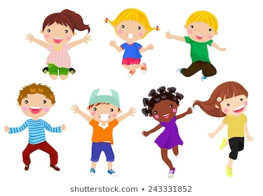

Once you have completed the session, tick it off on your sheet.
Decide how much you enjoyed the session and draw the correct number of smiley faces.
Type of Dance | Tick when complete | How much did you enjoy this session?
African drumming dance
Diwali stick dance
Samba

I liked it | I really enjoyed it. | I loved it | It was awesome.

