Fitness
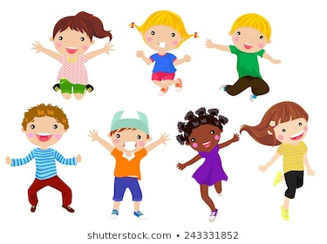

Once you have completed the session, tick it off on your sheet.
Decide how much you enjoyed the session and draw the correct number of smiley faces.
Fitness session | Tick when complete | How much did you enjoy this session?
Keeping healthy
Moving & growing
Muscles needed for movement
The importance of fitness

Balance 1

Balance 2

Co-ordination

I liked it | I really enjoyed it. | I loved it | It was awesome.

